1. The Policy Required is not necessary that it has to be from 1950’s in the drop-down list. It is mostly in the future. Let’s have option only from 2010 onwards.

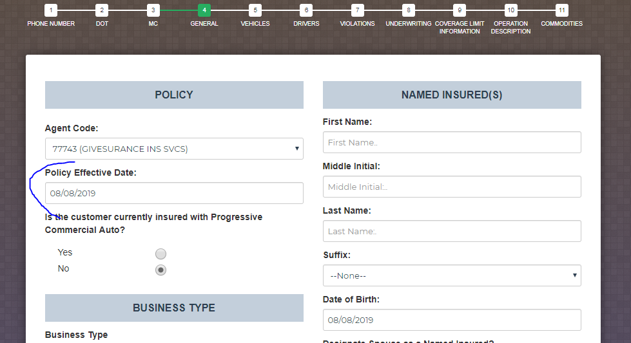

1. On General Tab, we don’t need Years in Business as -1, -2, -3 etc. only positive numbers.

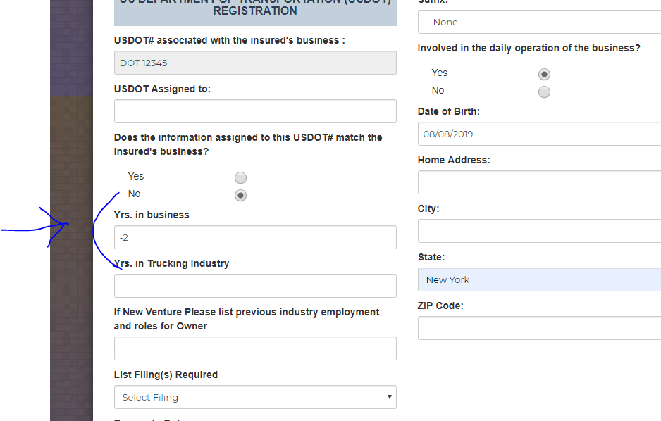

1. On same General Tab, for list of filings required (we would like options Federal/State).

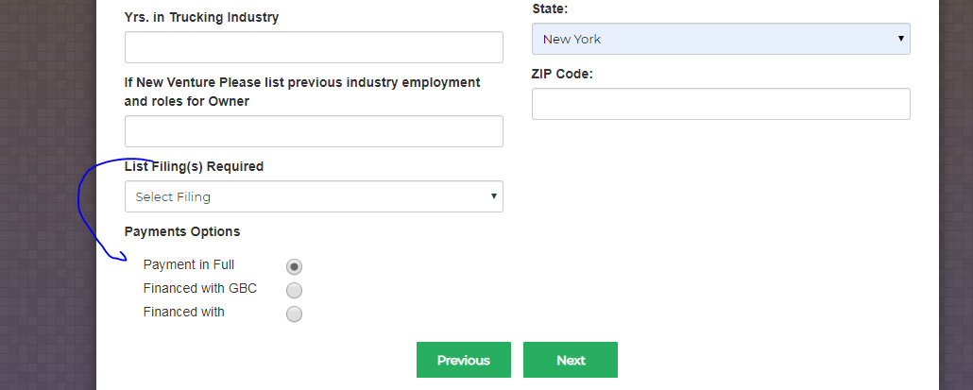

1. On Same General Tab, you have changed the Year of Birth, But the month is only till August, we need to add September, October, November, and December as well. Please Do the Same for Date of Birth Section Below.

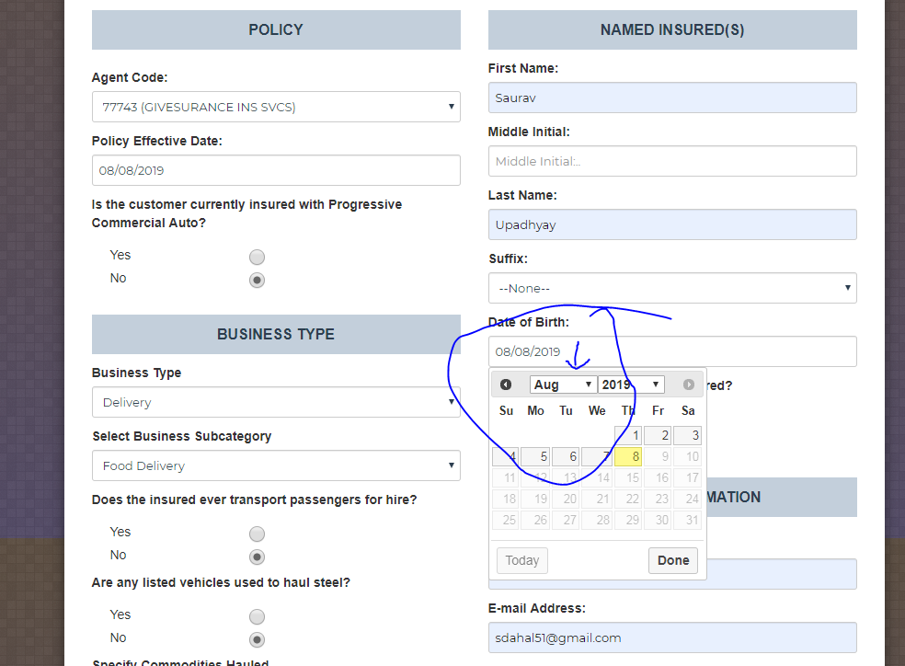

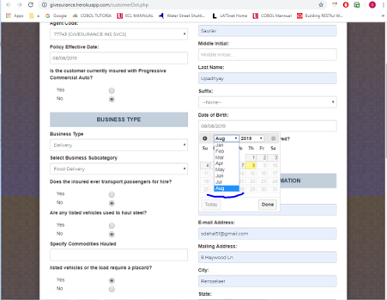

1. On adding the Make of the Vehicle, the drop down of all the list of manufacturers disappears. If there is way to fix it within one day then please do it soon, or else if it is time consuming then please let me know.

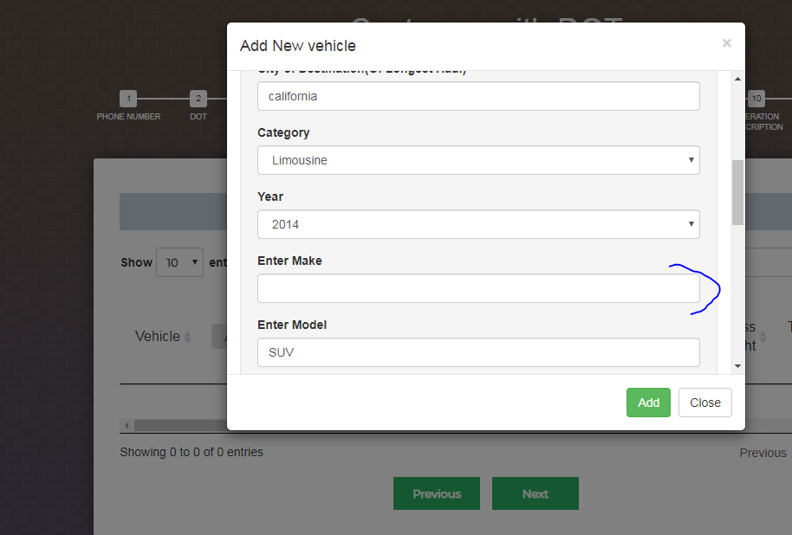

1. On Violation Page, if there is no violations then is it possible to keep NONE on Accident/Violation and the Date Field should be empty during display? And same thing here the month is only till August. Sept/Nov/Dec missing. Like I said earlier, we need this done by tomorrow. So let me know the time and effort for this change.

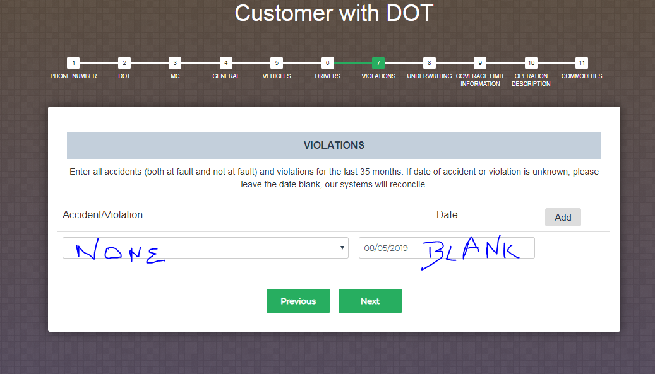

1. When I HIT NEXT in violation page, Obviously I used dummy data and dummy info, the system keeps on Loading forever. Is there any way to fix this? Also, like I said earlier, if this is massive change then please leave it. We can talk about this this evening.

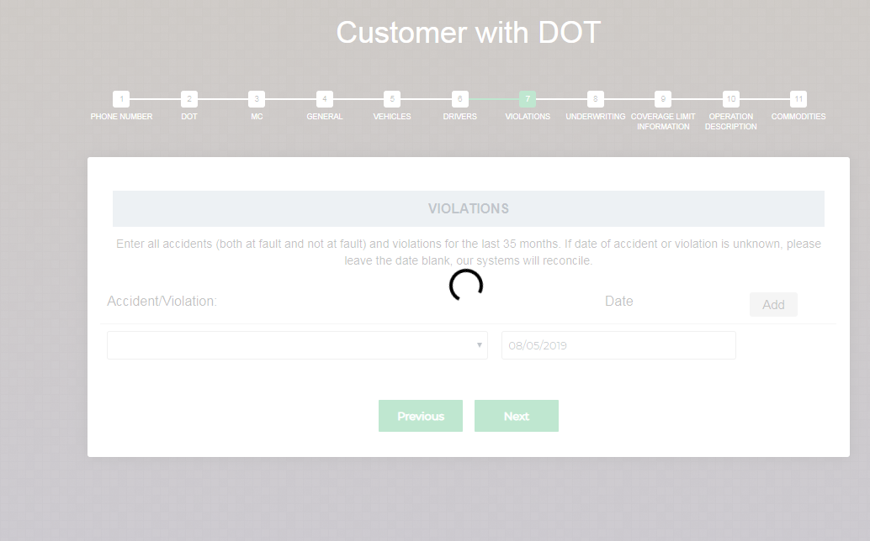

1. Please remove negative numbers and keep only from 0 till 50. It says 0-50 so it should be starting from 0 till 50 only. Same thing with other mileages as well. Let me know if this is massive change. We don’t want to waste our time since we have tight deadline.

